Dream

Writer: Emily Bonney, Shaye Trotta
Directors: Emily Bonney, Shaye Trotta

Cast
Norman - Norman Rivera

Sean - Ryan Kulas

Lisa - Paige Casavant

REHEARSAL SCHEDULE
April 27th | April 28th | April 29th | May 1st | May 4th
Afternoon | Before 2 |  | After 4 | Afternoon

May 5th | May 6th | May 10th | May 11th | May 13th
 |  | Afternoon | Afternoon

May 17th | May 30th
Afternoon | Before 5

VISUAL IMAGES
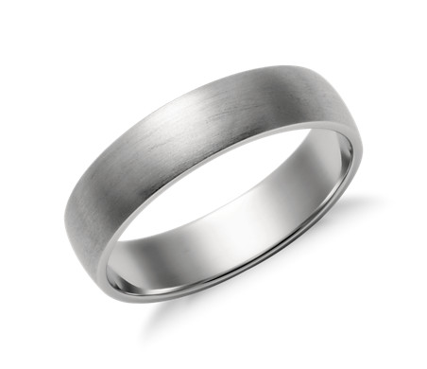
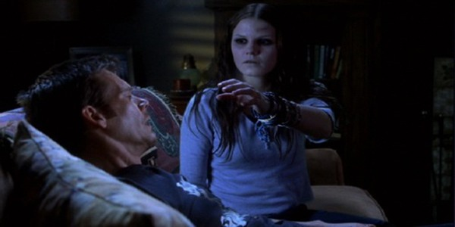

https://youtu.be/K-Vr2bSMU7o
https://www.youtube.com/watch?v=ZCXmk4QAcUc
Dream Sequence 1:
https://youtu.be/WR7cc5t7tv8
https://www.youtube.com/watch?v=-SkrX5lgbsg
Dream Sequence 2: House party/dance, hectic,
https://www.youtube.com/watch?v=4HaWlfHpaBo

SCRIPT ANALYSIS
Time Period: Modern Day
Place/Setting: House/bedroom/living room/kitchen, Record Store, Woods
Environmental facts: Suburban or small town
Society / Social Environment/Social Hierarchy: Modern society/social environment
Political environment:
Rules of your World:
PREVIOUS ACTION
Prior to the beginning of the story, Norman and Sean are in their college years, moving in together. They buy a house that is a fairly good price in for the budget.

CHARACTER ANALYSIS

NORMAN
Obstacles - Crush on Lisa, getting Sean to believe in him about Spirit
Objectives - Getting rid of Spirit
Conflicts - Himself vs Spirit, Self vs Self
Values - Friendship and Family, Honesty, Loyalty,
Personality traits - Anxious, careful, caring, charming, childish, dependent, easy going, gentle,
Relationships - Sean’s best friend, interested in Lisa, friends with Employee
SEAN
Obstacles - Spirit
Objectives - Help Norman with Spirit
Conflicts - Reality vs Spirit
Values - Friendship, Family Honesty, Loyalty
Personality traits - Active, ambitious, brave, charming, confident, courageous, easy going, independent,
Relationships - Norman’s best friend, acquaintance with Lisa and Employee
LISA
Obstacles - Singing
Objectives - Getting together with Norman
Conflicts - Self vs Self
Values - Family, friends, loyalty, honesty,
Personality traits - Admirable, attractive, charming, confident yet shy at times, friendly, gentle, kind,
Relationships - Love interest of Norman, acquaintance of Sean

COSTUME DESIGN
Norman: T-shirt and jeans, shoes, Starbucks or coffee shop uniform
Sean: Flannel over t-shirt, jeans, shoes
Lisa: flannel jeans, shoes
Employee: Coffee shop uniform

PROPERTIES

Scene 1
Duffel bag

Scene 2
Food
Ring
Duffel bag
Books

Scene 3
Sheet
Pillows
Laptop

Scene 4
Coffee cups
Trash can

Scene 5
Laptop
Scene 6
Umbrella
Ring
Laptop

Scene 7
Headphones

Scene 9
Ring

Scene 10
Bag
Phone

Scene 12
Ring

Scene 13
Blanket
Phone

